Potato Leaf Disease Classification Using CNN

|  |  |  |  |  |  |
| --- | --- | --- | --- | --- | --- |
| Shivam Tripathi | Dr Rajesh Kumar Tripathi | | | Akash Gupta | |
| Computer science engineering | | Assistant professor | Computer science engineering | |
| Gla University mathura | Gla University mathura | | | Gla University mathura | |
| shivam.tripathi1_cs18@gla.ac.in | rajesh.tripathi@gla.ac.in | | | akash.gupta_cs18@gla.ac.in | |

***Abstract***—**Globally, plant diseases adversely affect leaves, stems, roots, fruits, as well as crop quality and quantity, resulting in food shortages and insecurity. Crop disease losses are estimated to be roughly 16 percent of yearly production losses, making them the primary source of food shortages and price increases. According to a report published by the Food and Agriculture Organization (FAO), the world's population would reach9.1 billion by 2050. About 70% of food production increase is necessary for a stable food supply. Diseases and disorders are the conditions that damage plants and their products. Diseases produced by algae, fungus, or bacteria are biotic factors, whereas rainfall, moisture, temperature, and nutrient deprivation are biotic variables that in duceillnesses. For wheat, rice, maize, potatoes, soybeans, and cotton, estimates of prospective and actual losses despite existing crop protection techniques are provided on a regional level (19 areas) as well as for the world total for the years 2001–03. The overall worldwide potential loss owing to pests varied by crop, ranging from roughly 50% in wheat to more than 80% in cotton output. Soybean, wheat, and cotton losses are anticipated to be 26–29 percent, while maize, rice, and potatoes losses are estimated to be 31, 37, and 40 percent, respectively. Overall, weeds caused the greatest potential loss (34 percent), followed by animal pests and illnesses (losses of 18 and 16 percent).The early detection of plant leaf diseases could be a valuable source of information for executing proper diseases detection, plant growth management strategies and disease control measures to prevent the development and the spread of diseases. Deep learning constitutes a recent, modern technique for image processing and data analysis, with accurate results and large potential. As deep learning has been successfully applied in various domains, it has recently entered also the domain of agriculture. So, we will apply deep learning to create an algorithm for automated detection and classification of plant leaf diseases.**

***Keywords—*Potato Disease Detection, Image Processing, Neural Network,** **Convolutional Neural Network, Deep Learning**

1. **INTRODUCTION**

Potatoes are well known all over the world's people and also an important basic food in many countries around the world too. Potatoes are also called the root of all vegetables. As already known that, Bangladesh is an agricultural country and grows different kinds of crops, potatoes occupies a significant part in our country. Bangladesh is known as the 7th largest country for producing potatoes. Almost 5lakh hectares of land are used for cultivating potatoes every year and produced a minimum of

0.70 and a maximum of 1.09 crore tones according to the Department of Agricultural Extension (DAE). Potatoes play an important role in our economical balance system and agricultural economic situation too. The level of demand is growing across the world day by day, and it is also required to export as much as our region can, so the main aspect is increasingly producing potatoes. But the fact is in the last few years the export and produced level is decreasing because of some serious disease of potato leaf-like early blight, late blight, Brown spot, bacterial wilt, septoria blight etc. In that case, the production level is hampered badly. The farmers also have to suffer for this reason. Sometimes the disease is visible on the affected potato leaf. Sometimes spots come out on the leaf of the plant as well. Some diseases like brown spots, early blight, and late blight come out as small, oval, circular, and many other shapes. The symptoms of bacterial wilt can be seen in all parts of infected plants. The symptoms of septoria leaf spot can be seen with grey center & dark margin on leaves. The common disease of potato is early and late blight. Early blight's symptoms can be seen as small, black lesions mostly & late blight symptoms can be seen blistered as if scalded by hot water and eventually rot and dry out. To distinguish these disorders from potato leaves, a deep learning model will be offered and this will be very beneficial for farmers. This study is primarily focused on images, so that a large number of images are required. Three various types of processed images are accessible. They are early blight, healthy & late blight. The overall number of photos is isolated into two sections, one for training and the other for testing. Approximately 70% of the photographs are in the training portion and the remainder will be in the test section. The normal and diseased potato leaves would be classified by the proposed model. So that the diseases could not split across the civilized state, farmers can easily enhance their growth momentum.

1. **RELATED WORK**

To explore crop diseases forecasting, researchers used the machine learning, Support vector machines, RGB image analysis and so many other machine learning methods. Islam et al [1], a multi-class model of Support vector machine has also been conducted to determine potato diseases suppositions. The model was being used for 300 various pictures. Different operating parameters have been used to evaluate the efficiency of the model investigator, such as sensitivity, precision, F1- score and recall. Dubey et al [2] had used a multi-class Support vector machine forecasting model to train and verifypictures for apple diseases classification. Sladojevic et al [3], a deep Convolutional Neural Networks model has also been conducted to determine the infection of 13 folio considering apple & tomato flora. The method was used to determine the separation of 13 various illnesses among normal & injureleaves. Ferentinos et al [4], used AlexNetOWTBn's deep learning platform as well as VGG to distinguish 25 different diseases. For real-time recognition of tomato plant disease classifications Region-based fully convolutional network, Regions with convolutional neural networks & Solid State Drive were also exploited. A few studies [5-8] have been performed using deep learning for most of those classification task. Leemans et al [9], used K-Means clustering.

1. **METHODOLOGY**
2. ***Working Diagram***

A number of effective steps are required to detect potato leaf disease. Below the model block diagram is presented:

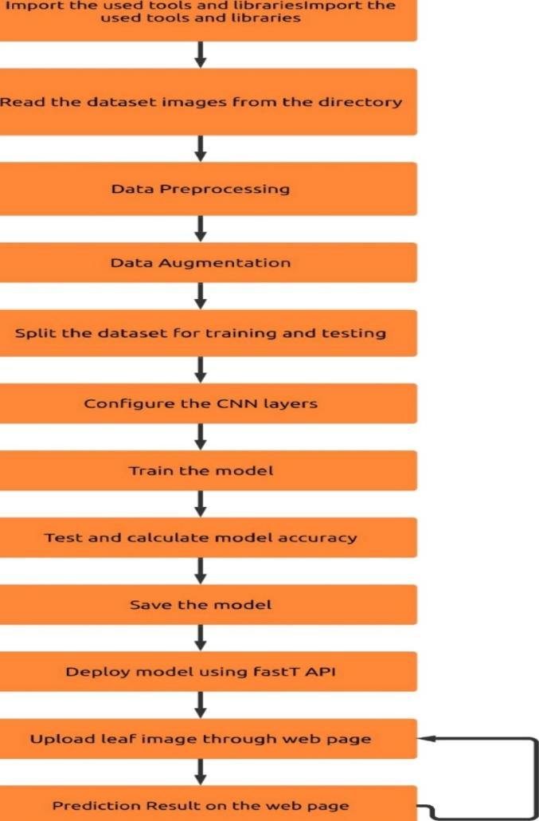

**Fig. 1.** Block Diagram.

At first, the images are gathered and then constructed for augmentation of the dataset. After augmented the dataset CNN model created for training and testing purposes. After completing the train and test the model finally detects and shows the result.

1. ***Gathering Datasets***

The major component of this project is data. Since we deal with photos, we need to obtain a large number of images. So we need to be aware of some important things like image sizes, resolutions, image quality when the images are gathered and also about the syndrome of the diseased leaves of potato. At first, the image data is collected from Kaggle, Dataset and some manual images are taken as much as possible. Almost 3000 images were collected and merged. But not all the

combined pictures are so helpful for us. The resolution of certain images is too low, some are hardly detected as affected and unaffected. It is why for the training ambition, 500 images are assigned for early blight, healthy & late blight. Similarly, to evaluate ambition, 300 images are selected per directory. The dataset used for this analysis is not reasonably safe. This is why a system of data processing should be completed to get our preferred modeling data.

**REFERENCES**

1. Islam, Monzurul, Anh Dinh, Khan Wahid, and Pankaj Bhowmik. "Detection of potato diseases using image segmentation and multiclass support vector machines." In 2017 IEEE 30th Canadian conference on electrical and computer engineering (CCECE), pp. 1-4. IEEE, 2017.
2. Dubey, Shiv Ram, and Anand Singh Jalal. "Detection and classification of apple fruit diseases using complete local binary patterns." In 2012 Third International Conference on Computer and Communication Technology, pp. 346-351. IEEE, 2012.
3. Sladojevic, Srdjan, Marko Arsenovic, Andras Anderla, Dubravko Culibrk, and Darko Stefanovic. "Deep neural networks based recognition of plant diseases by leaf image classification." Computational intelligence and neuroscience 2016 (2016).
4. Ferentinos, Konstantinos P. "Deep learning models for plant disease detection and diagnosis." Computers and Electronics in Agriculture 145 (2018): 311-318.
5. Fuentes, Alvaro, Sook Yoon, Sang Kim, and Dong Park. "A robust deep- learning-based detector for real-time tomato plant diseases and pests recognition." Sensors 17, no. 9 (2017): 2022.
6. Oppenheim, Dor, Guy Shani, Orly Erlich, and Leah Tsror. "Using Deep Learning for Image-Based Potato Tuber Disease Detection." Phytopathology ja (2018).
7. Hanson, A. M. G. J., M. G. Joel, A. Joy, and J. Francis. "Plant leaf disease detection using deep learning and convolutional neural networks." International Journal of Engineering Science5324 (2017).
8. Barbedo, Jayme GA. "Factors influencing the use of deep learning for plant disease recognition." Biosystems engineering 172 (2018): 84 -91.
9. Leemans, Vincent, Hugo Magein, and M-F. Destain. "Defects segmentation on ‘Golden Delicious’ apples by using colour machine vision." Computers and Electronics in Agriculture 20, no. 2 (1998): 117-130.